T.A.P. (Tag. Ask. Post.)
An AI-Assisted Pre-Publishing Checkpoint for Social Media Posts
Project Proposal:
Functions and Features, Profile of Target Users,
and Graphical User Interface of Major Functions
Live system: https://tagaskpost.com

Submitted by: [Full Name of Student/s]
[Course, Year and Section]
Submitted to: [Name of Instructor]
[Name of School/University]
October 2026
Table of Contents
1. Introduction 5
1.1 Background of the Project 5
1.2 Statement of the Problem 5
1.3 Purpose of this Document 6
2. Project Overview 7
2.1 Project Description 7
2.2 Objectives of the Project 7
2.3 Scope and Delimitations 8
3. Profile of Target Users 9
3.1 Basis of the Profile 9
3.2 User Segments 10
3.3 Gender Considerations 11
3.4 Behavioral and Psychographic Characteristics 11
3.5 User Personas 11
3.6 Administrator Profile 12
4. Functions and Features of the System 13
4.1 Summary of Functions and Features 13
4.2 Detailed Description of Major Functions with GUI Screenshots 14
5. Non-Functional Features 41
5.1 Technology Stack 42
6. Limitations of the System 43
7. Conclusion 44
References 45
Appendix A: Sample Inputs Used for the Screenshots 46

List of Figures
Figure 1. Landing Page (Hero Section) 15
Figure 2. The Tag–Ask–Post Walkthrough on the Landing Page 16
Figure 3. The Six Kinds of Findings Presented as Hanging Tags 17
Figure 4. Draft Composer with Caption, Photos and Tagged People 18
Figure 5. Review in Progress 20
Figure 6. Review Results: Summary, Category Filters and Annotated Draft 21
Figure 7. Annotated Draft with Numbered Highlights and Image Regions 22
Figure 8. People and Consent Tag with a Generated Consent Request Message 23
Figure 9. Fact-Check Tags: A Supported Claim and a Contradicted Claim with Linked Sources 24
Figure 10. Fact-Check Tags: An Unverifiable Claim and a Non-Factual Statement 25
Figure 11. Privacy Tags for an Exposed Home Address and an Access Code in a Screenshot 26
Figure 12. Media Tag and Approximate Regions Marked on the Uploaded Images 27
Figure 13. Context Tag and Sensitive-Topic Note 28
Figure 14. Final Checklist 29
Figure 15. Completion Screen with Copy-Caption Action and Feedback Form 30
Figure 16. Mobile Review Layout 31
Figure 17. Privacy Architecture Section of the Landing Page 32
Figure 18. Privacy Page 33
Figure 19. Example of an Error Message (Empty Draft) 34
Figure 20. Glossary of Review Labels on the How It Works Page 34
Figure 21. Administrator Sign-In Page 35
Figure 22. Administrator Dashboard 36
Figure 23. AI Settings with Masked API Key and Connection Status 37
Figure 24. Check Toggles and Site Settings 38
Figure 25. Audit Log 39
Figure 26. Account Page (Change Password) 40
List of Tables
Table 1. Demographic and Technographic Profile of Target Users 9
Table 2. Target User Segments and Their Needs 10
Table 3. Illustrative User Personas 12
Table 4. Summary of System Functions and Features 13
Table 5. Non-Functional Features (Quality Attributes) 41
Table 6. Technology Stack 42

1. Introduction

1.1 Background of the Project
Social media has become the default channel through which people share their lives, opinions and news. In the Philippines, 90.8 million social media user identities were recorded in January 2025, equivalent to 78.0 percent of the total population, and 83.8 percent of the population was online (Kemp, 2025). The same platforms that make sharing effortless also make it easy to publish other people before asking them: friends are tagged in photos they never approved, bystanders appear in the background of public posts, and screenshots of private conversations circulate with names, numbers and addresses still visible.
Information quality is a parallel concern. In the 2025 Digital News Report, only 38 percent of Filipino respondents said they trust news overall, while social media remained their preferred news source (Chua, 2025). A post that repeats an unverified figure, a mistaken date, or an allegation about an identifiable person can spread long before anyone checks it. At the same time, the Data Privacy Act of 2012 (Republic Act No. 10173) recognizes personal information as something that deserves protection, yet individual users rarely have a practical tool to apply that principle at the moment they press “Post.”
The familiar advice “think before you post” relies on users remembering to pause. T.A.P. (Tag. Ask. Post.) turns that advice into a concrete step: a web-based, AI-assisted pre-publishing checkpoint where a user places a draft (caption, photos or screenshots, a link, and the names of people tagged) and receives a calm, structured review before the content goes public.

1.2 Statement of the Problem
This project addresses the following general problem: social media users lack a convenient, privacy-respecting way to check a draft post for consent, accuracy, privacy and context issues before publishing it. Specifically, the project seeks to answer the following questions:
- How can users be reminded to identify and ask the people who appear in, or are mentioned in, their posts before publishing?
- How can factual claims in a draft be separated from opinion and checked against current, citable sources without inventing references?
- How can personal information unintentionally exposed in captions, photos and screenshots (for example, addresses, phone numbers, e-mail addresses and access codes) be detected and flagged?
- How can wording that may accuse, misrepresent or remove context be highlighted without censoring the user’s opinion?
- How can such a service be offered without itself becoming a store of users’ private drafts?

1.3 Purpose of this Document
This document enumerates the functions and features of the proposed system, describes the profile of its target users (including age, gender and other demographic, behavioral and technological characteristics), and presents screenshots of the graphical user interface (GUI) of its major functions. All screenshots were captured from the working system deployed at https://tagaskpost.com.

2. Project Overview

2.1 Project Description
T.A.P. is a responsive web application that acts as an “AI-powered preflight check” for social media posts. The name describes the method it promotes:
- Tag — identify who is involved: people tagged, people mentioned, people visible in images, and bystanders.
- Ask — determine whether anyone should approve the post first, and help the user ask them.
- Post — leave the final decision with the user, who now has the full picture.
The system does not publish anything, does not connect to the user’s social media accounts, and never blocks or scores a post. Its guiding principle is to inform, warn and ask rather than forbid: every finding explains what was found, where it was found, and what the user might consider doing. The interface uses the visual metaphor of a tag (a luggage-style label with a punched hole) that is attached to the exact words or area of a photo that a finding concerns.

2.2 Objectives of the Project
General objective. To develop a web-based, AI-assisted pre-publishing checkpoint that helps social media users review drafts for consent, factual accuracy, privacy and context before posting, while keeping the user in control of the final decision.
Specific objectives. The project specifically aims to:
- provide a draft composer that accepts a caption, photos or screenshots, a link, the intended platform and audience, and the names of tagged people;
- detect people involved in a post and generate consent questions and ready-to-send consent request messages;
- extract and classify statements (factual claim, opinion, satire, personal experience, prediction, accusation) and verify check-worthy claims against live web sources, displaying only sources that the search actually returned;
- detect personal and sensitive information in text and images and suggest practical remedies such as cropping, blurring or rewording;
- present findings in an annotated, mobile-friendly “proof view” with a final checklist;
- implement privacy-by-design processing in which drafts and images are not permanently stored; and
- provide a secure administration panel for configuration, anonymous analytics and audit logging.

2.3 Scope and Delimitations
The system covers the review of a single draft at a time, consisting of up to 5,000 characters of text and up to four images (both limits are configurable by the administrator). It supports drafts intended for Facebook, Instagram, X, TikTok, Threads, LinkedIn, Reddit and other platforms. The following are outside the scope of the current version:
- posting to, or reading from, any social media account;
- identification of people through facial recognition (the system only counts and describes people neutrally);
- legal advice or determinations of legality;
- automatic blurring of images (findings provide approximate regions that make this a future enhancement); and
- user accounts or saved drafts for the public (the public service is intentionally anonymous).

3. Profile of Target Users

3.1 Basis of the Profile
The target user profile was derived from published secondary data on social media use in the Philippines and internationally, and from the requirements of the system. The primary reference for demographic figures is the Digital 2025: The Philippines report (Kemp, 2025), supplemented by the Pew Research Center survey of social media use (Gottfried & Park, 2025) and the Digital News Report 2025 country page for the Philippines (Chua, 2025). The system itself does not collect age, gender or any other personal attribute of its users; the profile below describes the intended audience for design purposes.
Table 1
Demographic and Technographic Profile of Target Users
Attribute | Target Profile | Basis / Rationale
Age | Primary: 18–34 years old.  Secondary: 13–17 years old (with guidance) and 35–54 years old.  Minimum recommended age: 13. | Ages 18–24 and 25–34 make up 13.0% and 17.1% of the Philippine population; the median age is 26.1 (Kemp, 2025). Eight in ten U.S. adults aged 18–29 use Instagram (Gottfried & Park, 2025). Age 13 matches the usual minimum age of major platforms.
Gender | All genders; gender-neutral design and language. | Of Philippine social media user identities, 52.2% are female and 47.8% male (Kemp, 2025), so a slightly larger share of female users is expected. No feature is gender-specific.
Location | Primarily the Philippines (urban and peri-urban areas); usable worldwide. | 97.5 million internet users in the Philippines at the start of 2025 (Kemp, 2025). The web app needs no installation and works in any modern browser.
Education | Secondary school to tertiary level and above. | Interface copy is written in plain English at an accessible reading level; findings are returned in the language of the draft where possible.
Occupation | Students, young professionals, content creators, small business owners, teachers, and organization page administrators. | These groups post frequently, often involve other people (classmates, customers, students), and carry reputational risk from mistakes.
Devices | Smartphones (primary); laptops and desktops (secondary; required for administrators). | Social media use is predominantly mobile; the GUI is mobile-first with a dedicated phone layout.
Platforms used | Facebook, Instagram, TikTok, X, Threads, LinkedIn, Reddit and others. | The composer lets users select the target platform so the review can be tailored to it.
Digital literacy | Basic to intermediate. | No account, sign-up or technical knowledge is required; the flow has three steps (Draft, Review, Ready).
Socio-economic | All levels; the service is free to use and light on data. | Photos are compressed on the user’s device before upload, reducing mobile data usage.
Accessibility needs | Users of keyboards, screen readers and reduced-motion settings. | The GUI follows WCAG-conscious practices (W3C, 2023): visible focus, labels, live regions, and no reliance on color alone.

3.2 User Segments
Five user segments are defined. The first four are end users of the public review tool; the fifth operates the system.
Table 2
Target User Segments and Their Needs
Segment | Age | Description | Primary Needs | Key Features Used
A. Young adults (primary) | 18–34 | College students, young professionals and creators who post daily, often with friends in frame. | Avoid posting people without consent; avoid sharing unverified claims; protect location and identity. | People & consent, consent message, fact-check, privacy, mobile review
B. Teen users (secondary) | 13–17 | High school students, ideally guided by parents or teachers. | Learn safe posting habits; protect classmates and personal details such as school and routine. | Privacy check, minor-related warnings, plain-language explanations
C. Adults and parents (secondary) | 35–54 | Parents, professionals and small business owners posting about family, work or products. | Protect children’s information; avoid misleading business claims; protect customers in photos. | Privacy and media checks, fact-check with sources, wording suggestions
D. Institutional posters | Any adult | Teachers, school publication staff, and organization or local page administrators. | Accuracy and consent before posting on behalf of an organization. | Fact-check, consent check, sensitive-topic context, final checklist
E. System administrator | Adult | The technically capable operator of the deployment. | Configure the AI service, monitor usage and errors, secure the system. | Admin login, dashboard, settings, audit log, account security

3.3 Gender Considerations
Because Philippine social media users are close to evenly split between women (52.2 percent) and men (47.8 percent) (Kemp, 2025), and because the system serves all users regardless of gender identity, T.A.P. uses gender-neutral language throughout. The AI is explicitly instructed not to infer gender, ethnicity, religion, health or other sensitive traits from images, and to describe people only by count and neutral position or clothing (for example, “person in a red jacket, background left”). The system does not ask for, store or analyze the gender of its users.

3.4 Behavioral and Psychographic Characteristics
Beyond demographics, the intended users share the following characteristics:
- Frequent posters who share photos involving other people (friends, family, classmates, customers).
- Privacy-aware but time-constrained: they want to do the right thing but will not read long guidelines before posting.
- Concerned about misinformation, in a context where trust in news is low and social media is a primary news source (Chua, 2025).
- Reputation-conscious, particularly creators, professionals and organization page administrators whose posts carry their name or brand.
- Mobile-first, preferring short, scannable feedback over long reports.

3.5 User Personas
The following personas are hypothetical composites created to guide design decisions; they are not real individuals.
Table 3
Illustrative User Personas
Persona | Background | Goals and Frustrations | How T.A.P. Helps
Bea Santos  20, female  College student, Quezon City | Posts group photos from org events on Instagram and TikTok several times a week. | Wants to share memories but was once asked by a friend to take down an unflattering photo. | Flags people in the photo, asks “Do they know?”, and writes a message she can send before posting.
Marco Dela Cruz  34, male  Small business owner, Cebu | Runs a Facebook page for his food business and posts promos and customer photos. | Worried about posting a claim he cannot back up, or a customer’s face without permission. | Checks claims against live sources and points out customers visible in photos.
Ms. Liza Ramos  42, female  Public school teacher | Manages the school’s Facebook page and posts announcements and event photos. | Must protect students’ identities and avoid sharing schedules or locations publicly. | Detects children, school names, routines and screens or documents in the background.
Alex Tan  27, non-binary  Freelance content creator | Posts commentary on X and Threads, often quoting screenshots of other posts. | Fears accidentally misquoting someone or exposing a stranger’s username or number. | Reads text inside screenshots, flags personal data, and suggests wording that separates opinion from fact.

3.6 Administrator Profile
The administrator is an adult with intermediate to advanced technical skills (for example, a school ICT coordinator, an IT student or a web developer) who can use the cPanel hosting control panel, obtain an AI service API key, and read basic analytics. Administrators use a desktop or laptop computer. The panel is not linked from public pages and requires a username and password.

4. Functions and Features of the System

4.1 Summary of Functions and Features
Table 4 summarizes the functions of T.A.P. Features F1 to F17 are used by the public; features F18 to F24 support administration and operation. Each major function is described in Section 4.2 together with screenshots of its graphical user interface.
Table 4
Summary of System Functions and Features
ID | Feature | Function | Users
F1 | Landing page and onboarding | Explains the Tag–Ask–Post method, what is checked, how sources work and how privacy is protected. | All
F2 | Draft composer | Accepts caption, platform, audience, photos/screenshots, tagged names and an optional link. | A–D
F3 | On-device image preparation | Resizes and re-encodes photos in the browser (removing hidden GPS metadata) and warns when an original photo contains location data. | A–D
F4 | AI review engine | Two-pass analysis: a core review of text and images, then web-based verification of factual claims. | A–D
F5 | People and consent check | Identifies tagged, mentioned and pictured people and bystanders; asks whether they agreed; offers four responses. | A–D
F6 | Consent request message | Generates a short, editable message the user can copy and send to the people involved. | A–D
F7 | Fact-checking with verified sources | Classifies statements; verifies check-worthy claims; shows status, evidence, context and linked sources; suggests corrections. | A–D
F8 | Privacy check | Detects addresses, phone numbers, e-mail addresses, codes, IDs, plates, documents and other personal information. | A–D
F9 | Image and screenshot review | Reviews photos and screenshots and marks approximate regions worth cropping or blurring. | A–D
F10 | Context and wording check | Flags wording that may accuse, speculate, mislead or overshare; suggests alternative wording. | A–D
F11 | Sensitive-topic context | Adds a neutral note for topics such as health, elections, safety, allegations or children. | A–D
F12 | Annotated proof view and filters | Shows the draft with numbered highlights and image regions linked to tag notes; filters by category. | A–D
F13 | Final checklist and completion | A self-check before posting and a completion screen with a copy-caption action; nothing is published. | A–D
F14 | Feedback | Optional anonymous rating and comment on the review. | A–D
F15 | Mobile review experience | Dedicated phone layout with a collapsible draft, swipeable tag deck and bottom action dock. | A–D
F16 | Privacy-first processing and disclosure | Drafts and images are not stored; a privacy page explains exactly what is processed and kept. | All
F17 | Error handling | Clear, non-technical messages for empty drafts, oversized files, timeouts, limits and service outages. | All
F18 | Administrator authentication | Password sign-in with rate limiting, secure sessions and automatic timeout. | E
F19 | Administrator dashboard | Anonymous aggregate analytics: reviews, processing time, findings per category, errors, feedback. | E
F20 | AI and system configuration | Encrypted API key, model, reasoning effort, checks on/off, limits, maintenance mode, connection test. | E
F21 | Audit log | Records sign-ins and configuration changes, without secret values. | E
F22 | Account management | Lets the administrator change the password. | E
F23 | Secure installer | One-time web installer protected by a setup token; locks itself after use. | E
F24 | Scheduled cleanup | Background job that deletes stale temporary files and expired records. | System
Note. Users refer to the segments in Table 2: A = young adults, B = teens, C = adults and parents, D = institutional posters, E = system administrator.

4.2 Detailed Description of Major Functions with GUI Screenshots

F1. Landing Page and Onboarding
The landing page introduces the product with the headline “Check your post before the internet does.” An illustrated example post shows three tags hanging from the exact words and photo areas they refer to (consent, privacy and a claim needing a source), so first-time visitors immediately understand what a review looks like. The primary action, Check a post, opens the review tool.
Figure 1
Landing Page (Hero Section)
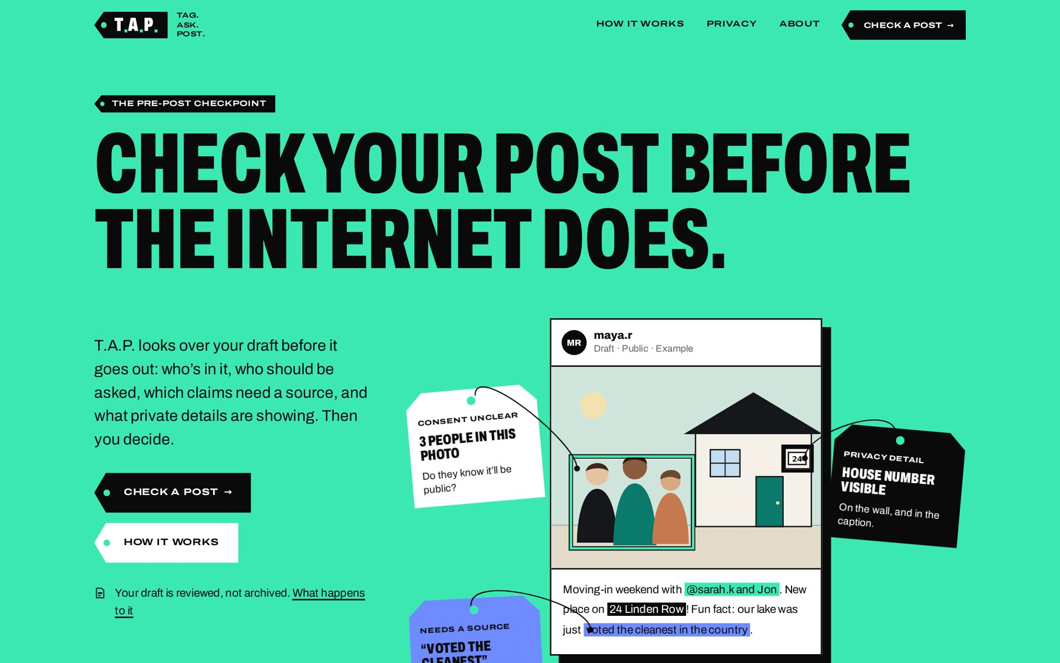
Note. Screenshot of the live T.A.P. system at https://tagaskpost.com, captured on October 2, 2026. The example post and its tags are an illustration.
Further down, the page explains the method in five steps (Tag, Ask, Check, Protect, Post) and presents the six kinds of finding as a row of hanging tags.
Figure 2
The Tag–Ask–Post Walkthrough on the Landing Page
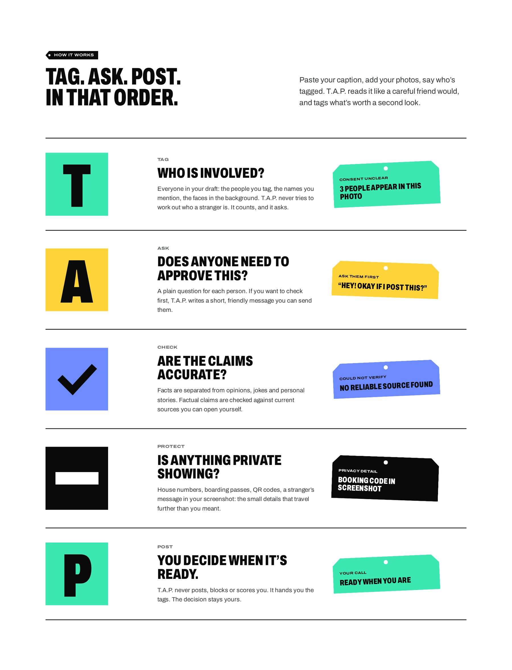
Note. Screenshot of the live T.A.P. system at https://tagaskpost.com, captured on October 2, 2026.
Figure 3
The Six Kinds of Findings Presented as Hanging Tags
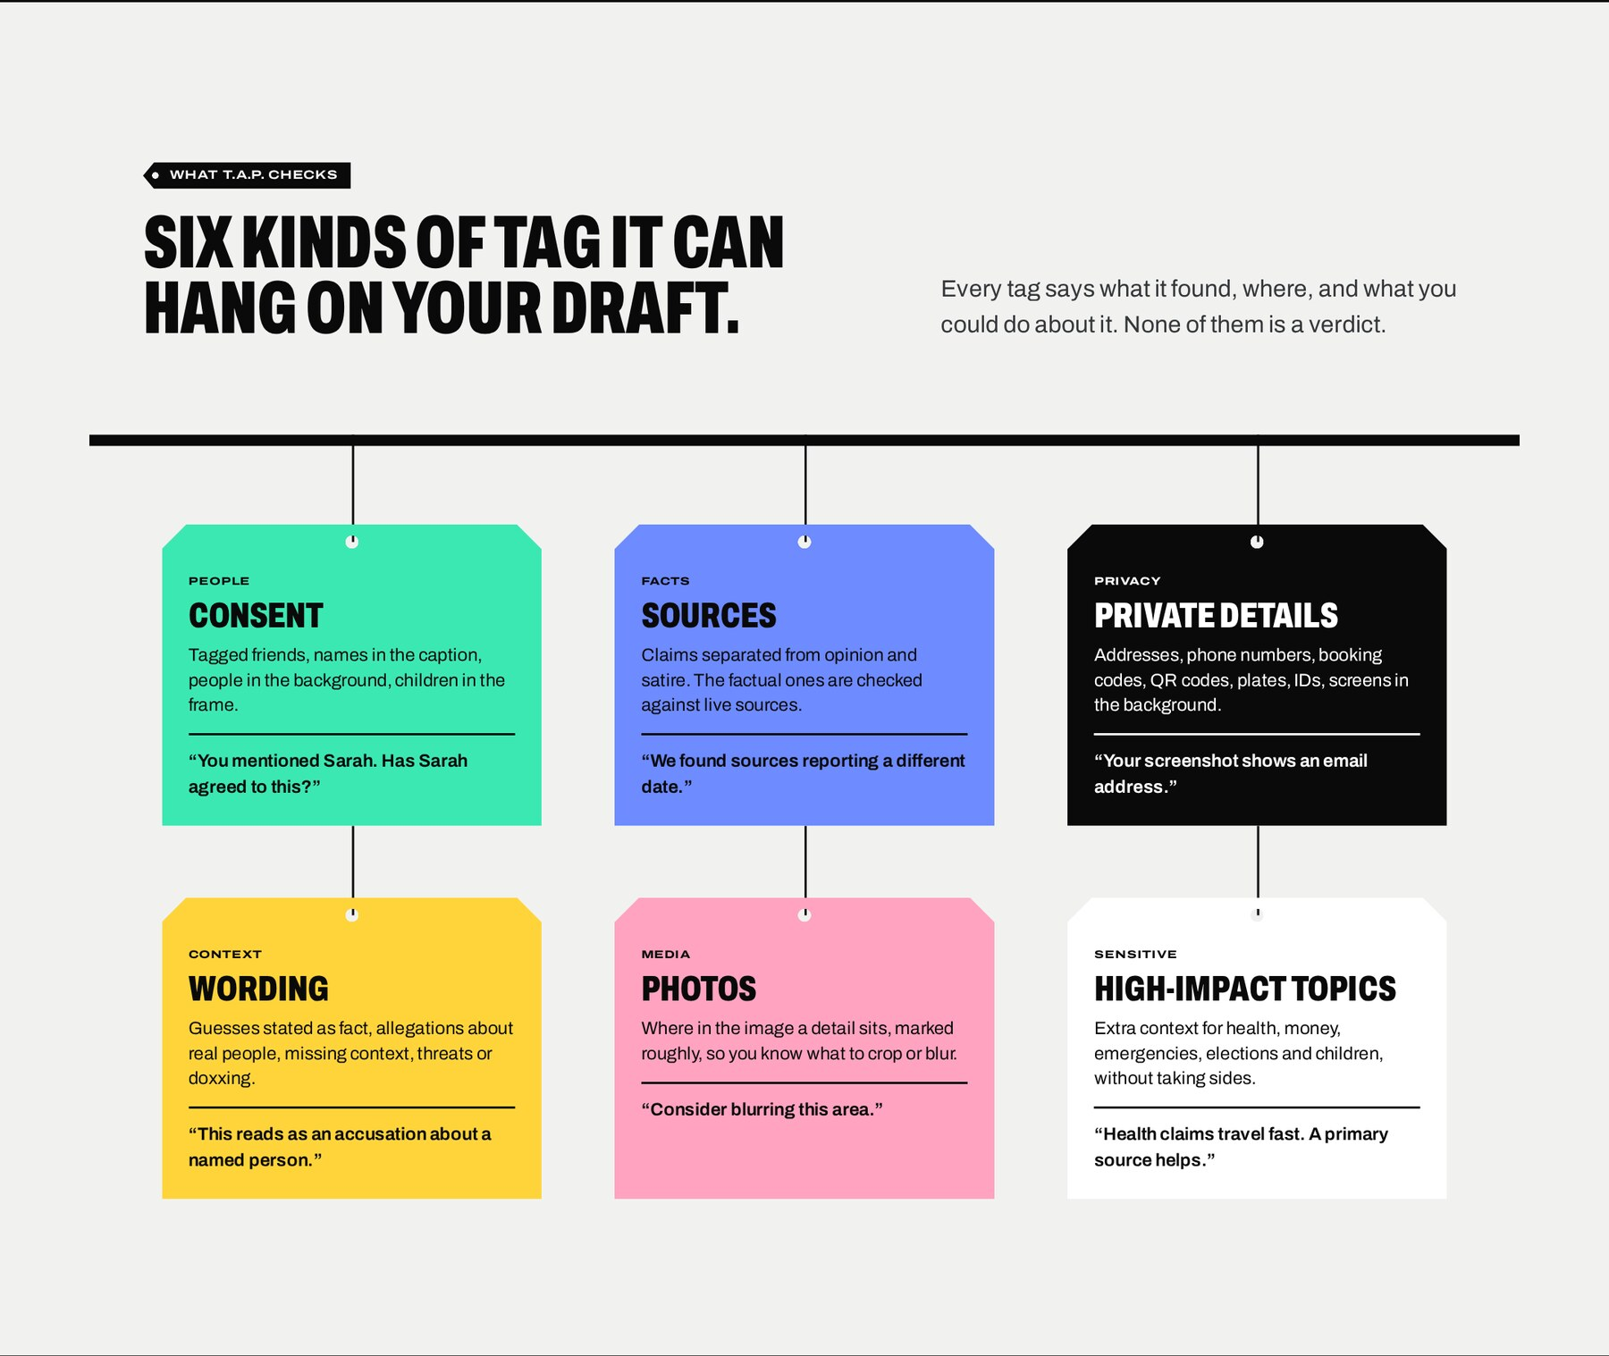
Note. Screenshot of the live T.A.P. system at https://tagaskpost.com, captured on October 2, 2026.

F2. Draft Composer
The composer is the first of three steps shown in the progress rail (Draft → Review → Ready). The user selects the platform (Facebook, Instagram, X, TikTok, Threads, LinkedIn, Reddit or Other) and the intended audience (Public, Friends/Followers, Private group, Close friends, Professional or Other), pastes the caption, adds up to four photos or screenshots by drag-and-drop, file picker or pasting, enters the names of people tagged (shown as removable tag chips), and optionally adds the link that will accompany the post. A character counter enforces the length limit, and a permanent notice states that the draft is analyzed for the review and not kept as a post archive.
Figure 4
Draft Composer with Caption, Photos and Tagged People
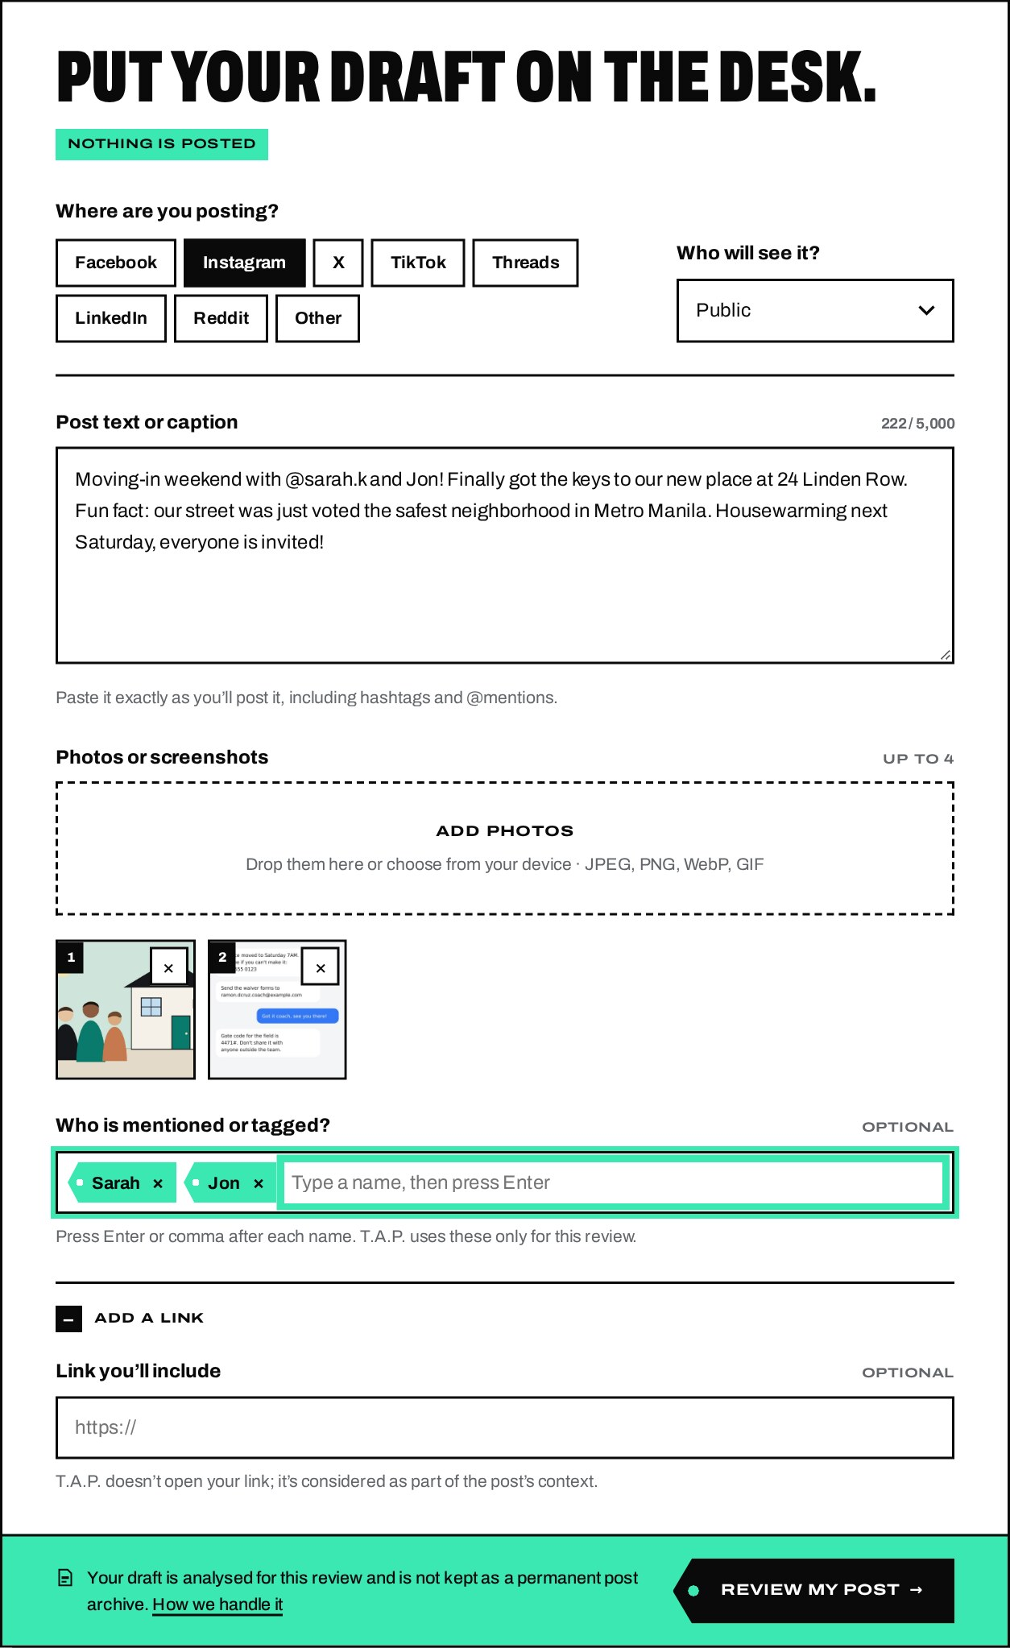
Note. Screenshot of the live T.A.P. system, captured on October 2, 2026. The review content was generated by the system’s artificial intelligence (AI) in response to a fictitious sample post (see Appendix A); the people, address, phone number, e-mail address and gate code shown are invented for demonstration.

F3. On-Device Image Preparation
Before upload, each photo is decoded, resized to a maximum of 2,048 pixels and re-encoded in the user’s browser. This reduces upload size on mobile data and removes hidden metadata such as GPS coordinates. The browser also checks the original file for a GPS block; if one is found, the thumbnail is marked “Has location data” and the review includes a note, labeled “Checked on your device,” explaining that the original file still carries the location.

F4. AI Review Engine
When the user selects Review my post, the draft is sent over HTTPS to the T.A.P. server, which validates the input, converts images in memory, deletes the temporary files, and sends the draft to a large language model (LLM) for a structured review. While the review runs, the draft is displayed with a moving scan bar and a list of the checks in progress. The review proceeds in two passes: (1) a core review of people, privacy, wording, images and claim extraction; and (2) a separate fact-checking pass that uses live web search and never receives the user’s photos. Results appear as soon as the first pass completes, and fact-check results fill in afterward.
Figure 5
Review in Progress
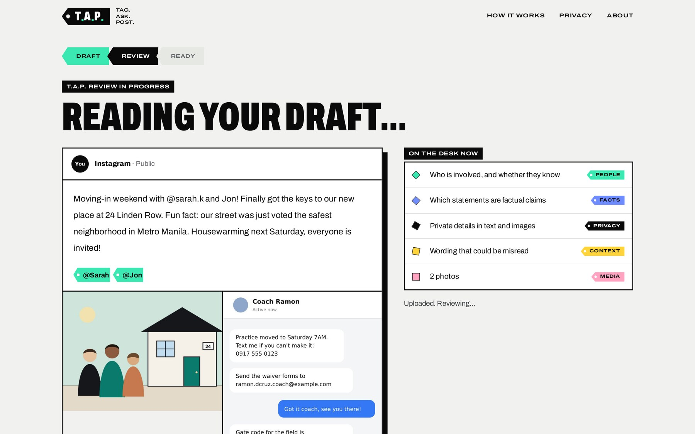
Note. Screenshot of the live T.A.P. system, captured on October 2, 2026. The review content was generated by the system’s artificial intelligence (AI) in response to a fictitious sample post (see Appendix A); the people, address, phone number, e-mail address and gate code shown are invented for demonstration.

F12. Annotated Proof View and Category Filters
The review screen states how many items are worth checking, gives a one-sentence neutral summary of the post, and offers category filters (All notes, People, Facts, Privacy, Context, Media) with counts. The user’s draft is displayed as a “proof”: affected words are highlighted in the color of their category with a reference number, and areas of photos are outlined. Selecting a highlight scrolls to the matching tag note, and hovering over a note highlights its marks. Privacy highlights are shown in solid black, like a redaction.
Figure 6
Review Results: Summary, Category Filters and Annotated Draft
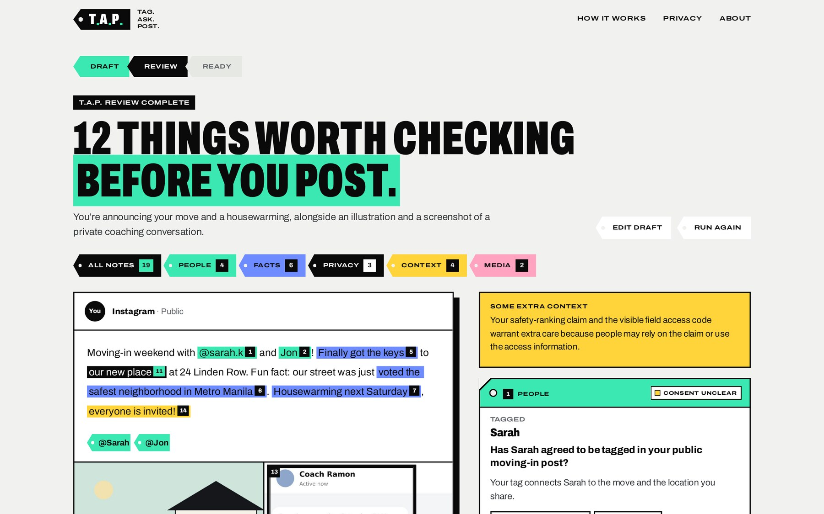
Note. Screenshot of the live T.A.P. system, captured on October 2, 2026. The review content was generated by the system’s artificial intelligence (AI) in response to a fictitious sample post (see Appendix A); the people, address, phone number, e-mail address and gate code shown are invented for demonstration.
Figure 7
Annotated Draft with Numbered Highlights and Image Regions
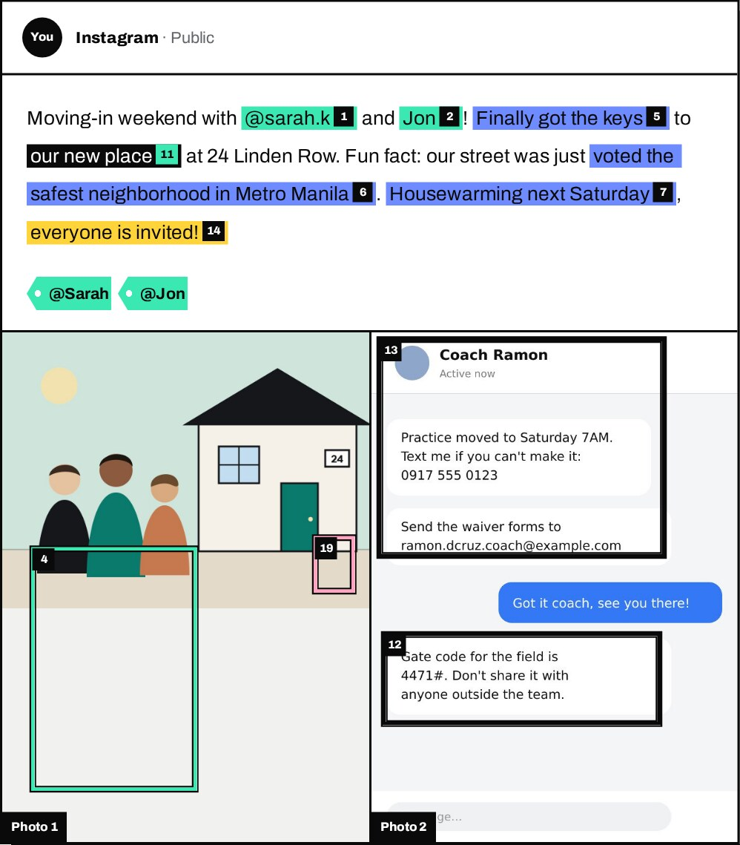
Note. Screenshot of the live T.A.P. system, captured on October 2, 2026. The review content was generated by the system’s artificial intelligence (AI) in response to a fictitious sample post (see Appendix A); the people, address, phone number, e-mail address and gate code shown are invented for demonstration.

F5 and F6. People and Consent Check, and Consent Request Message
For each person or group involved, a People tag states the role (tagged, mentioned, in the photo, in the background, or subject of the post) and asks a specific consent question. If consent is unclear, the user can choose Yes, I have permission, Ask them first, Remove / blur them, or Not applicable. Choosing Ask them first reveals a short, friendly message, written by the AI for the platform and audience, which the user can edit and copy. Choosing Remove / blur them shows practical guidance. When a child appears to be involved, the tag adds advice about asking a parent or guardian.
Figure 8
People and Consent Tag with a Generated Consent Request Message
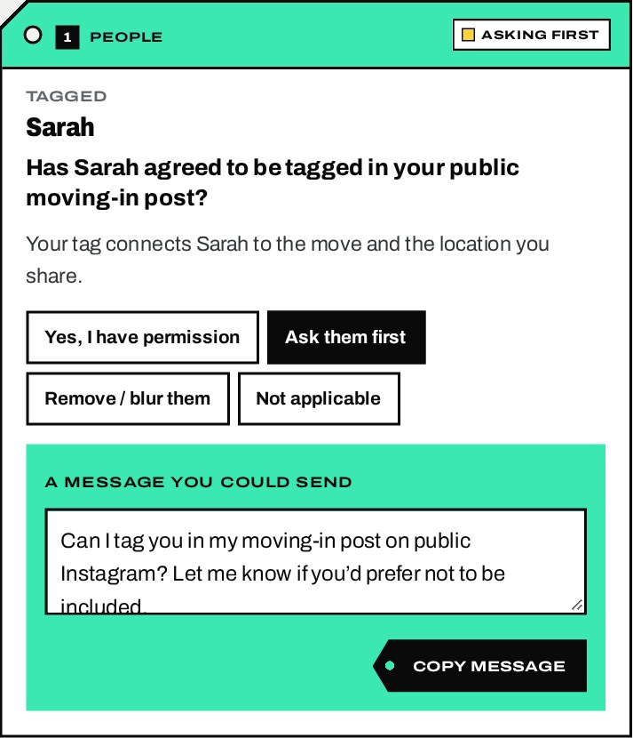
Note. Screenshot of the live T.A.P. system, captured on October 2, 2026. The review content was generated by the system’s artificial intelligence (AI) in response to a fictitious sample post (see Appendix A); the people, address, phone number, e-mail address and gate code shown are invented for demonstration.

F7. Fact-Checking with Verified Sources
Each statement is classified as a factual claim, opinion, satire, personal experience, prediction, unsupported accusation or unverifiable statement. Check-worthy factual claims are verified with live web search, and each result shows the claim, what T.A.P. found, the evidence, any context, the sources (title, publisher, date and whether each source supports, contradicts or adds context), and a suggested action. Possible outcomes are Supported by available sources, Conflicting information, Missing context, Could not verify, Time-sensitive information, and Opinion rather than factual claim. No truth percentage is ever shown.
A key safeguard is that the server compares every cited source against the list of pages that the web-search tool actually returned in the same request; any citation that does not match is removed, and a verdict left without sources is downgraded to Could not verify. Figure 9 shows a claim supported by two official sources and a claim with an incorrect figure that the sources contradict, together with a suggested correction.
Figure 9
Fact-Check Tags: A Supported Claim and a Contradicted Claim with Linked Sources
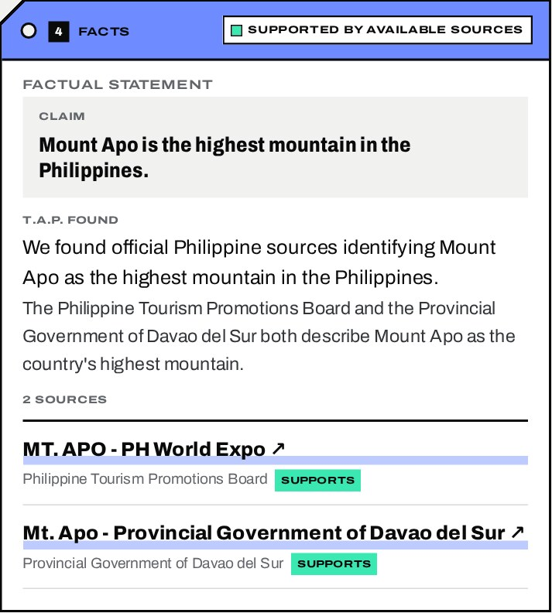  (a) Supported by available sources | 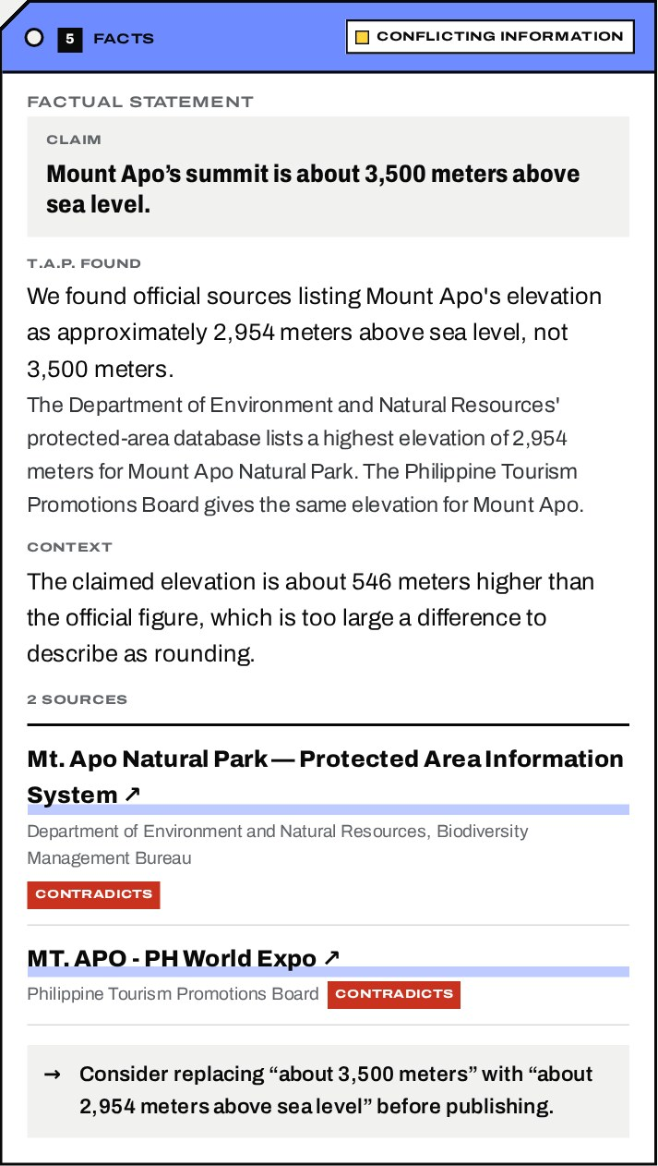  (b) Conflicting information
Note. Screenshot of the live T.A.P. system, captured on October 2, 2026, for Sample Post B (see Appendix A). Source titles and publishers are those returned by the system’s live web search.
Figure 10
Fact-Check Tags: An Unverifiable Claim and a Non-Factual Statement
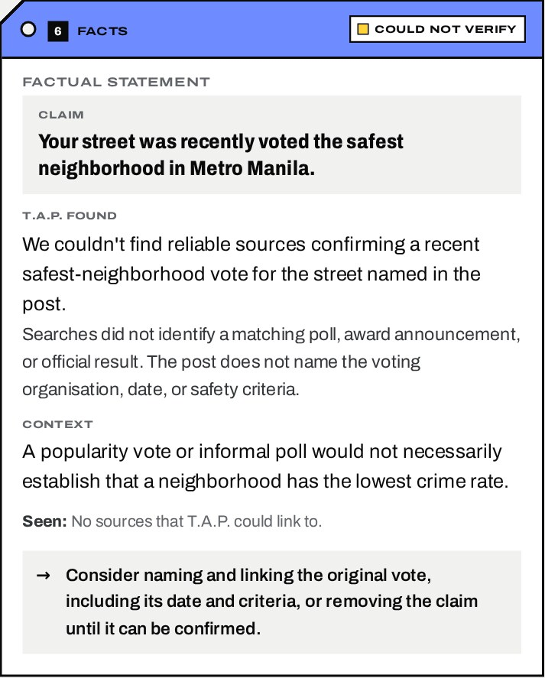  (a) Could not verify | 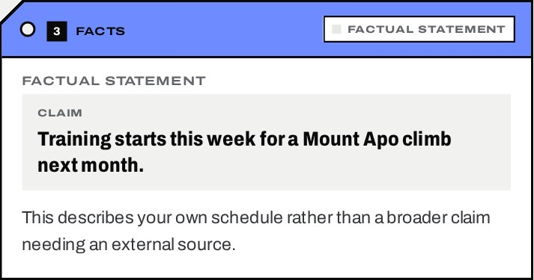  (b) Personal statement — no check needed
Note. Screenshot of the live T.A.P. system, captured on October 2, 2026. The review content was generated by the system’s artificial intelligence (AI) in response to a fictitious sample post (see Appendix A); the people, address, phone number, e-mail address and gate code shown are invented for demonstration. Panel (b) is from Sample Post B.

F8. Privacy Check
Privacy tags identify information that could expose the user or others, such as home addresses, phone numbers, e-mail addresses, usernames in screenshots, schools, workplaces, ID numbers, boarding passes, booking codes, QR codes and barcodes, vehicle plates, financial and medical information, real-time location, private conversations and documents or screens in the background. Each tag explains the concern, states what was seen (without repeating the full sensitive value), and suggests a remedy. Severity is labeled For your info, Privacy detail or Important; the “Important” level is reserved for significant exposure.
Figure 11
Privacy Tags for an Exposed Home Address and an Access Code in a Screenshot
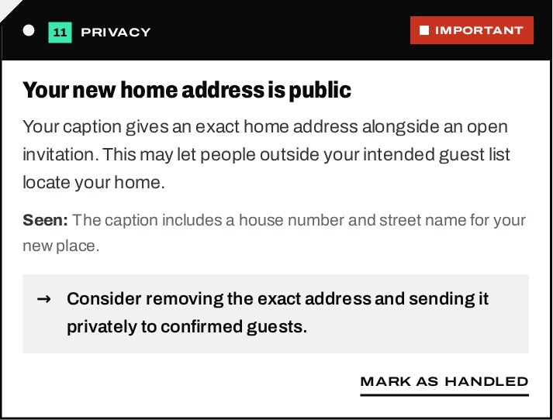  (a) Address in the caption | 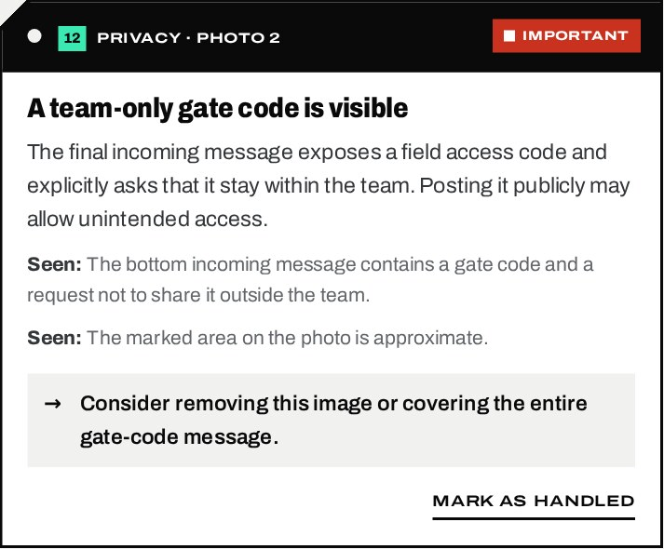  (b) Gate code inside a screenshot
Note. Screenshot of the live T.A.P. system, captured on October 2, 2026. The review content was generated by the system’s artificial intelligence (AI) in response to a fictitious sample post (see Appendix A); the people, address, phone number, e-mail address and gate code shown are invented for demonstration.

F9. Image and Screenshot Review
Media tags concern details inside photos and screenshots. Where a detail is in a specific area, the review returns an approximate region that is drawn on the photo with the matching reference number, helping the user decide what to crop or blur. The interface states that marked areas are approximate. Text visible in screenshots (for example, a phone number in a chat) is read and checked like the caption.
Figure 12
Media Tag and Approximate Regions Marked on the Uploaded Images
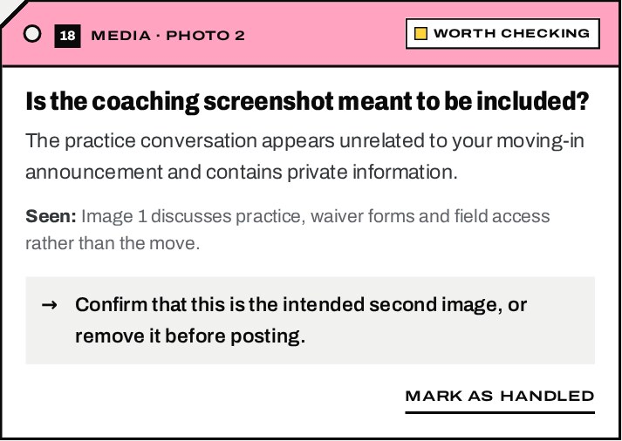  (a) Media tag | 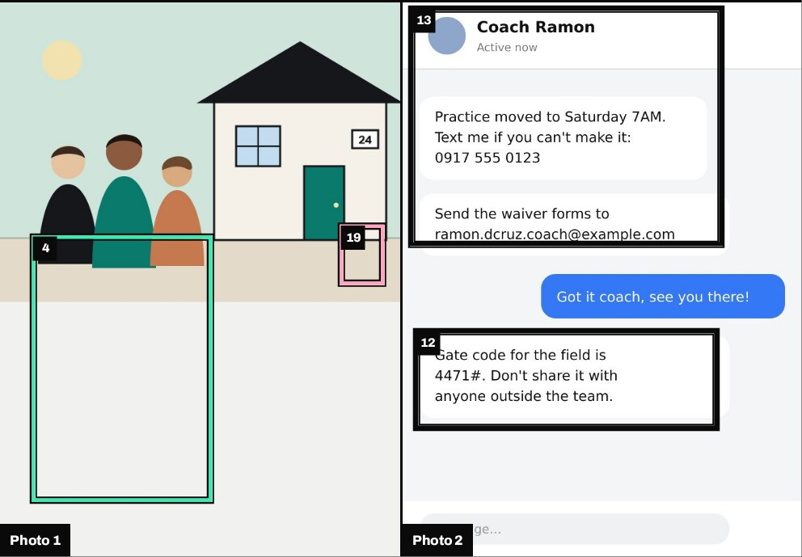  (b) Numbered regions on Photos 1 and 2
Note. Screenshot of the live T.A.P. system, captured on October 2, 2026. The review content was generated by the system’s artificial intelligence (AI) in response to a fictitious sample post (see Appendix A); the people, address, phone number, e-mail address and gate code shown are invented for demonstration.

F10 and F11. Context and Wording Check, and Sensitive-Topic Context
Context tags highlight wording that may unintentionally accuse an identifiable person, present speculation as fact, reveal something private about someone else, or drop important context. The system uses careful phrasing and does not issue legal judgments. Where a small change would help, it offers a suggested rewording with the original and suggested text side by side and a Copy suggestion action. When a post touches health, finance, emergencies, elections, public safety, allegations, children or crime, a yellow Some extra context note explains, neutrally, why extra care helps.
Figure 13
Context Tag and Sensitive-Topic Note
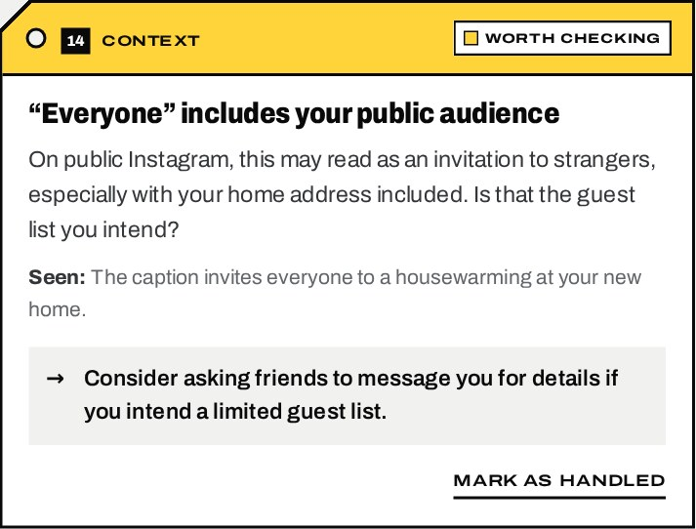  (a) Context and wording tag | 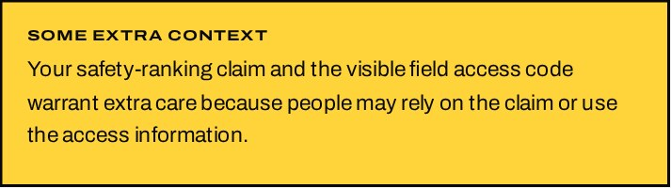  (b) Extra-context note
Note. Screenshot of the live T.A.P. system, captured on October 2, 2026. The review content was generated by the system’s artificial intelligence (AI) in response to a fictitious sample post (see Appendix A); the people, address, phone number, e-mail address and gate code shown are invented for demonstration.

F13 and F14. Final Checklist, Completion Screen and Feedback
At the end of the review, the user completes a short self-check: whether people shown have agreed, whether sensitive information is intentional, whether important claims were reviewed, and that posting will make the content available to the selected audience. Post-specific items suggested by the AI are appended. Selecting I’m ready to post does not publish anything; it closes the review and shows a completion screen with a Copy caption action, a reminder of any unticked items (“that’s your call”), and an optional feedback form. Edit draft and Run again return the user to the composer with the draft preserved.
Figure 14
Final Checklist
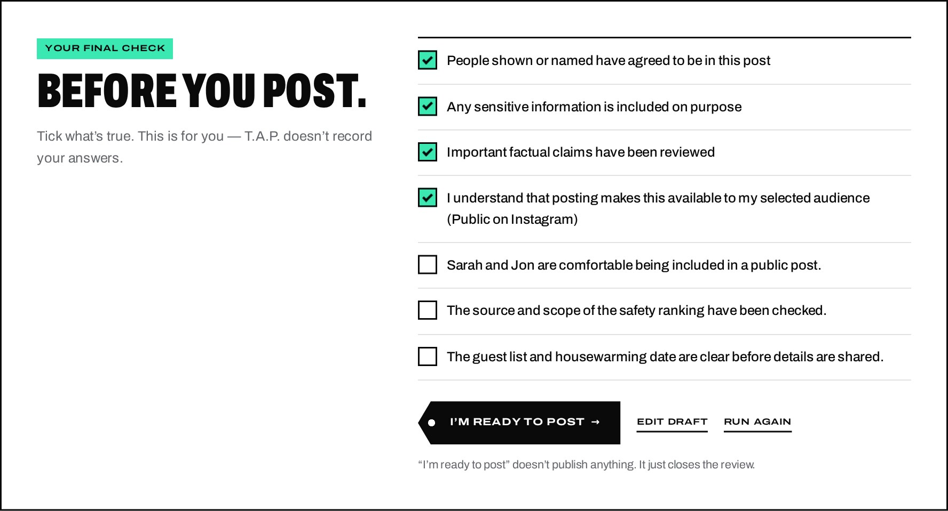
Note. Screenshot of the live T.A.P. system, captured on October 2, 2026. The review content was generated by the system’s artificial intelligence (AI) in response to a fictitious sample post (see Appendix A); the people, address, phone number, e-mail address and gate code shown are invented for demonstration.
Figure 15
Completion Screen with Copy-Caption Action and Feedback Form
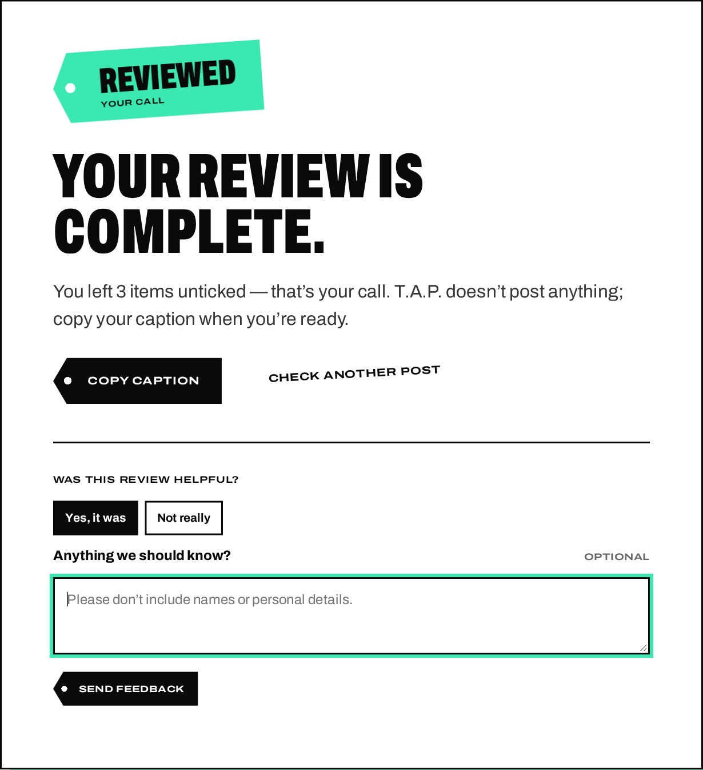
Note. Screenshot of the live T.A.P. system, captured on October 2, 2026. The review content was generated by the system’s artificial intelligence (AI) in response to a fictitious sample post (see Appendix A); the people, address, phone number, e-mail address and gate code shown are invented for demonstration.

F15. Mobile Review Experience
Because most users post from phones, the mobile layout is designed separately rather than simply stacked. The draft collapses to a preview with a Show full draft control, tag notes become a horizontally swipeable deck with previous and next buttons and a position counter (for example, “1 / 20”), the category filters scroll sideways, and a fixed bottom dock provides Edit and Final check actions while respecting device safe areas.
Figure 16
Mobile Review Layout
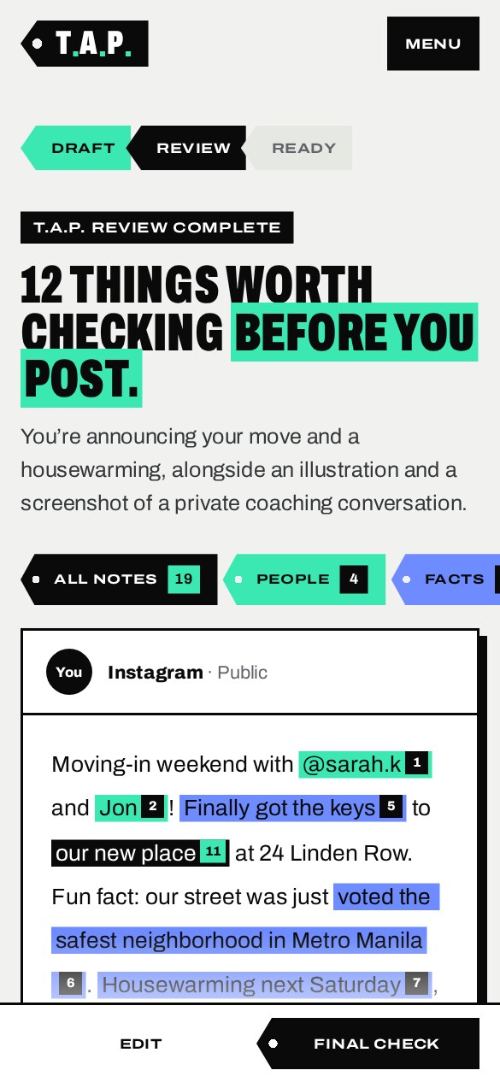  (a) Summary and annotated draft | 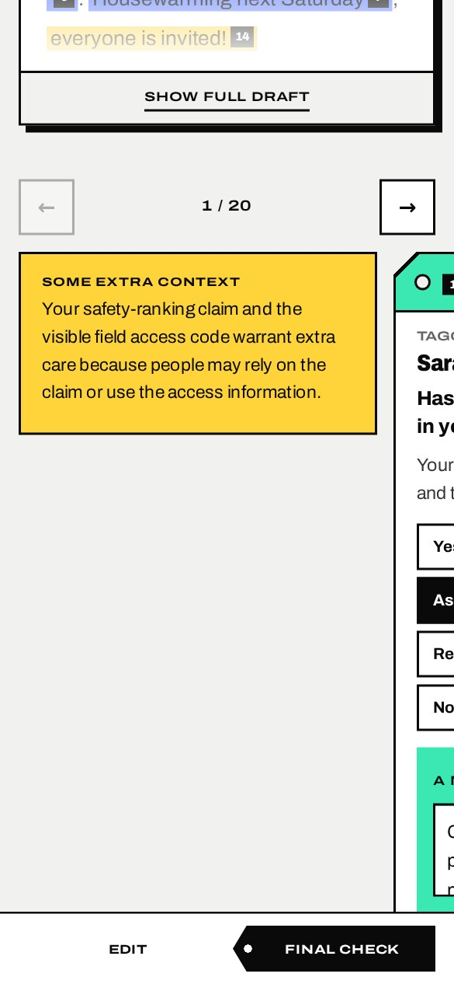  (b) Swipeable tag deck
Note. Screenshot of the live T.A.P. system, captured on October 2, 2026. The review content was generated by the system’s artificial intelligence (AI) in response to a fictitious sample post (see Appendix A); the people, address, phone number, e-mail address and gate code shown are invented for demonstration. Captured at a phone viewport width of 390 pixels.

F16. Privacy-First Processing and Disclosure
Privacy is built into the architecture. Uploaded files are written to a private temporary folder outside the public web root under random names, converted in memory, and deleted before the AI request is made; any file left by an interrupted request is deleted when the request ends, and a scheduled job removes anything older than 30 minutes. Captions, images, names, links and AI results are never written to the database, which stores only anonymous counts (for example, “2 privacy notes”). Requests to the AI service are sent with response storage disabled. The landing page summarizes this journey, and a dedicated Privacy page explains exactly what is sent, processed temporarily, stored and not stored.
Figure 17
Privacy Architecture Section of the Landing Page
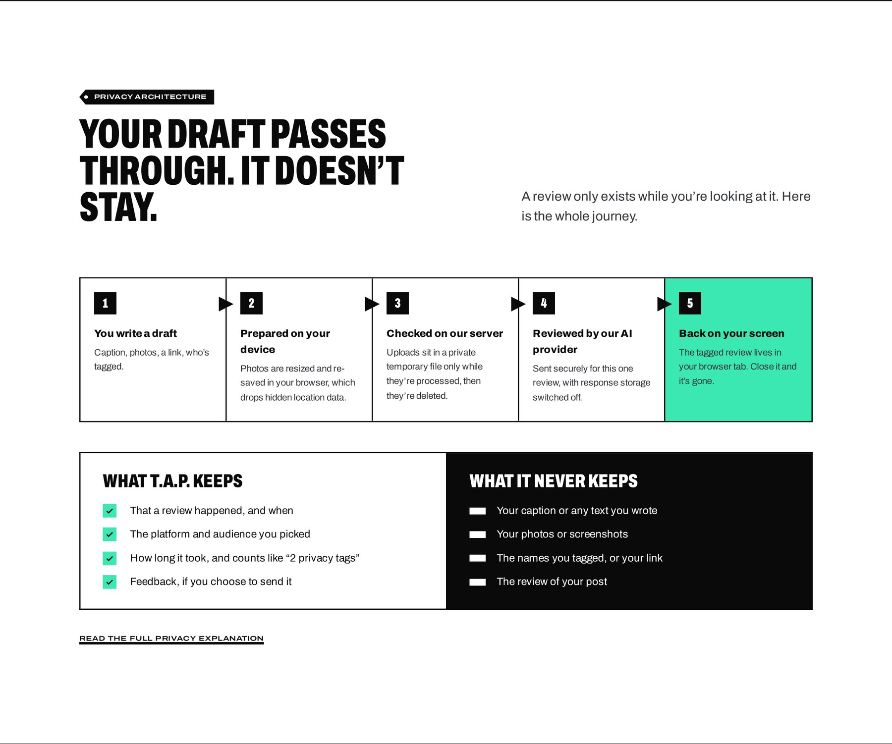
Note. Screenshot of the live T.A.P. system at https://tagaskpost.com, captured on October 2, 2026.
Figure 18
Privacy Page
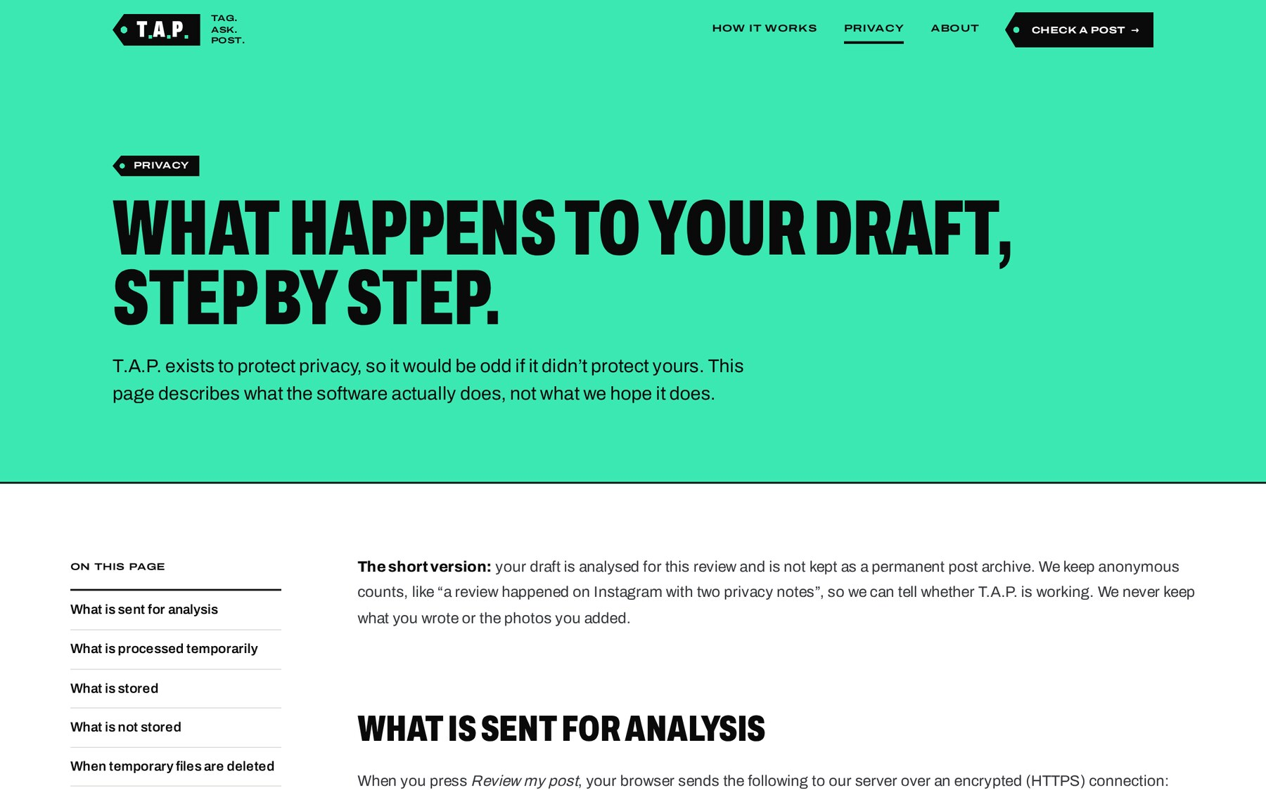
Note. Screenshot of the live T.A.P. system at https://tagaskpost.com, captured on October 2, 2026.

F17. Error Handling
Errors are presented in plain language with a suggested next step and without technical detail. Examples include an empty draft, an oversized or unsupported file, a slow connection, a review limit being reached (with the time until reset), maintenance mode, and the AI service being unavailable. If only the fact-checking pass fails, the rest of the review remains available with the message “We couldn’t complete the fact-check right now. Your privacy and consent checks are still available.” The user’s draft is always preserved. A glossary of status labels is published on the How it works page.
Figure 19
Example of an Error Message (Empty Draft)
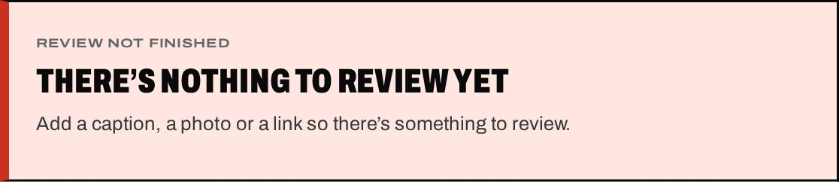
Note. Screenshot of the live T.A.P. system at https://tagaskpost.com, captured on October 2, 2026.
Figure 20
Glossary of Review Labels on the How It Works Page
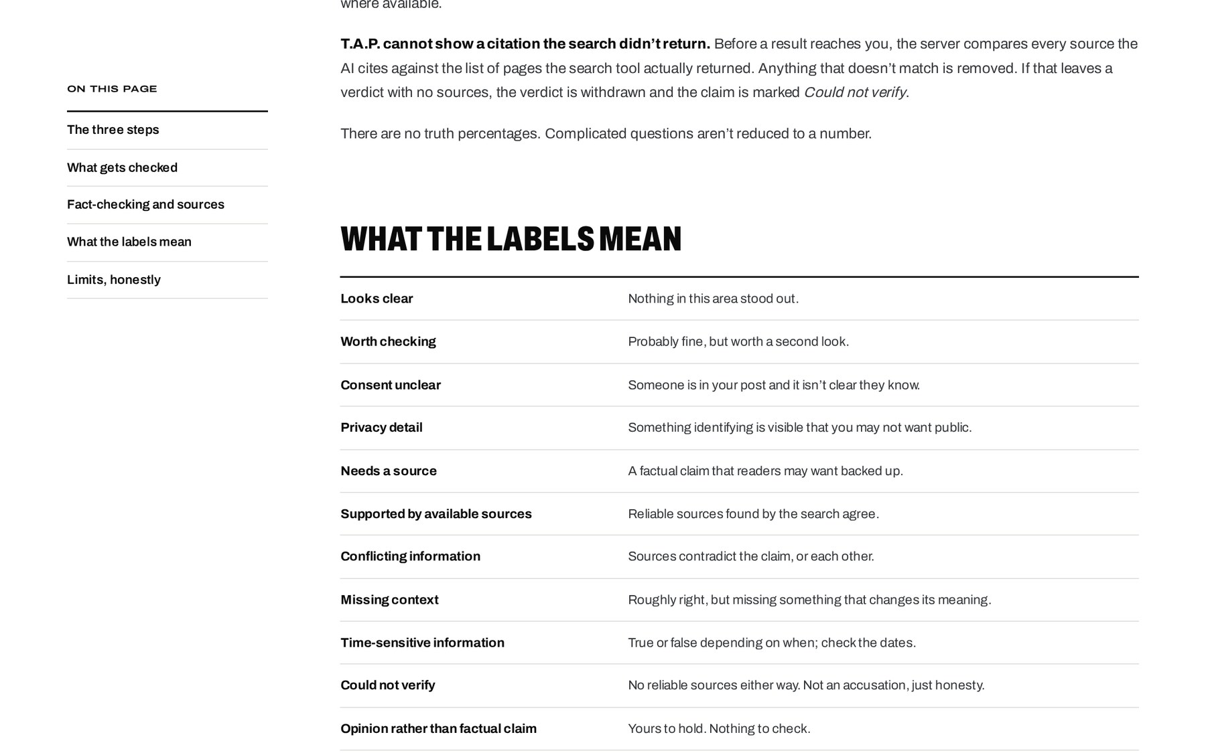
Note. Screenshot of the live T.A.P. system at https://tagaskpost.com, captured on October 2, 2026.

F18. Administrator Authentication
The administration panel at /admin is not linked from public pages. Administrators sign in with a username and password; passwords are stored as Argon2id hashes, sign-in attempts are limited per IP address and per username, every attempt is recorded in the audit log, and sessions expire after 30 minutes of inactivity or 8 hours in total.
Figure 21
Administrator Sign-In Page
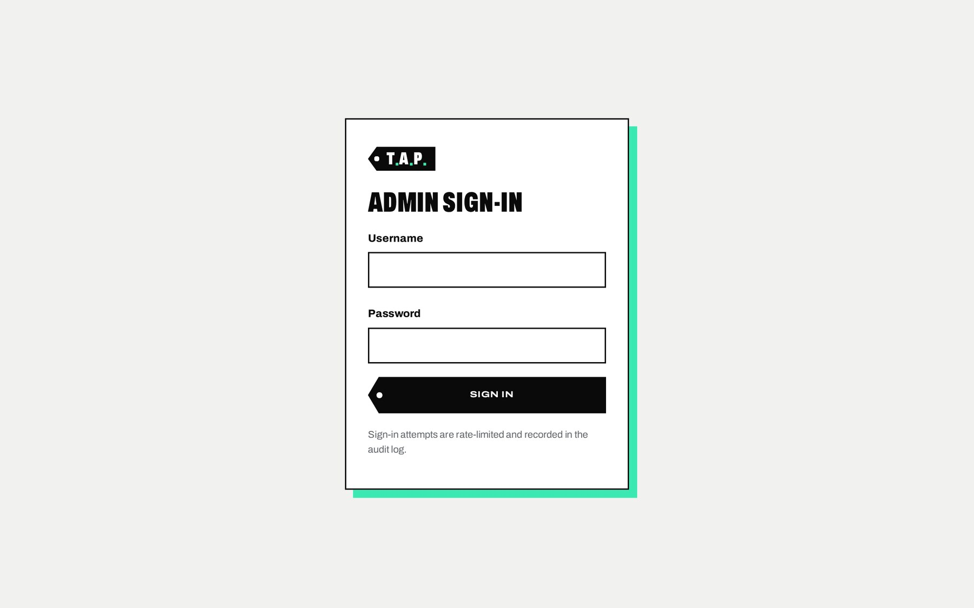
Note. Screenshot of the T.A.P. administration panel (restricted area), captured on October 2, 2026. Figures shown are anonymous aggregate counts; no post content is stored.

F19. Administrator Dashboard
The dashboard shows the status of the AI connection and privacy-safe aggregate statistics: reviews today, this week and in the last 30 days; average processing time; failed reviews; privacy warnings; consent reminders; claims fact-checked and sources cited; how many users revised their drafts; feedback; token usage; and breakdowns by day, check type, platform and error code. All figures are derived from anonymous counts.
Figure 22
Administrator Dashboard
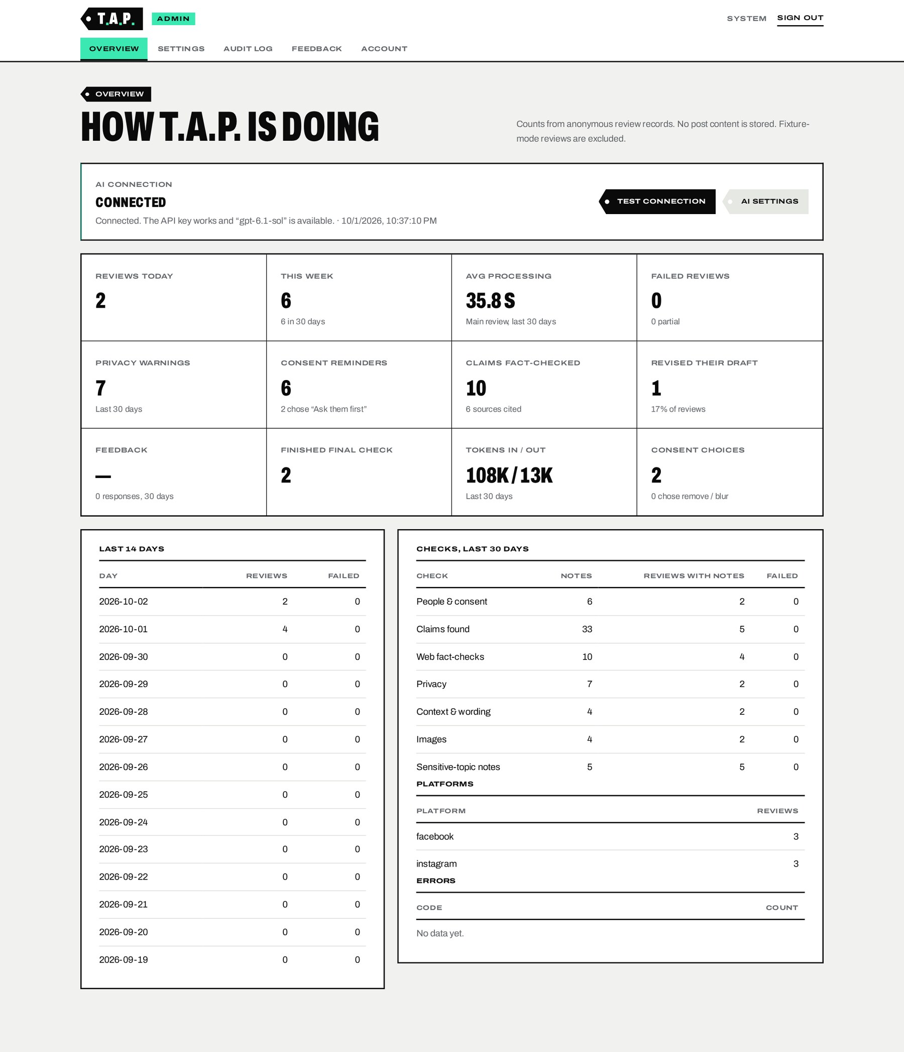
Note. Screenshot of the T.A.P. administration panel (restricted area), captured on October 2, 2026. Figures shown are anonymous aggregate counts; no post content is stored.

F20. AI and System Configuration
The Settings page lets the administrator enter the AI service API key (stored encrypted with AES-256-GCM and only ever displayed as a masked hint), choose the model and reasoning effort for the review and fact-checking passes, set image detail, temperature, output limits and request timeout, enable or disable web fact-checking, and test the connection. Further sections turn individual checks on or off, set limits (upload size, photos per review, post length and reviews per IP address per hour), and control maintenance mode and optional video review.
Figure 23
AI Settings with Masked API Key and Connection Status
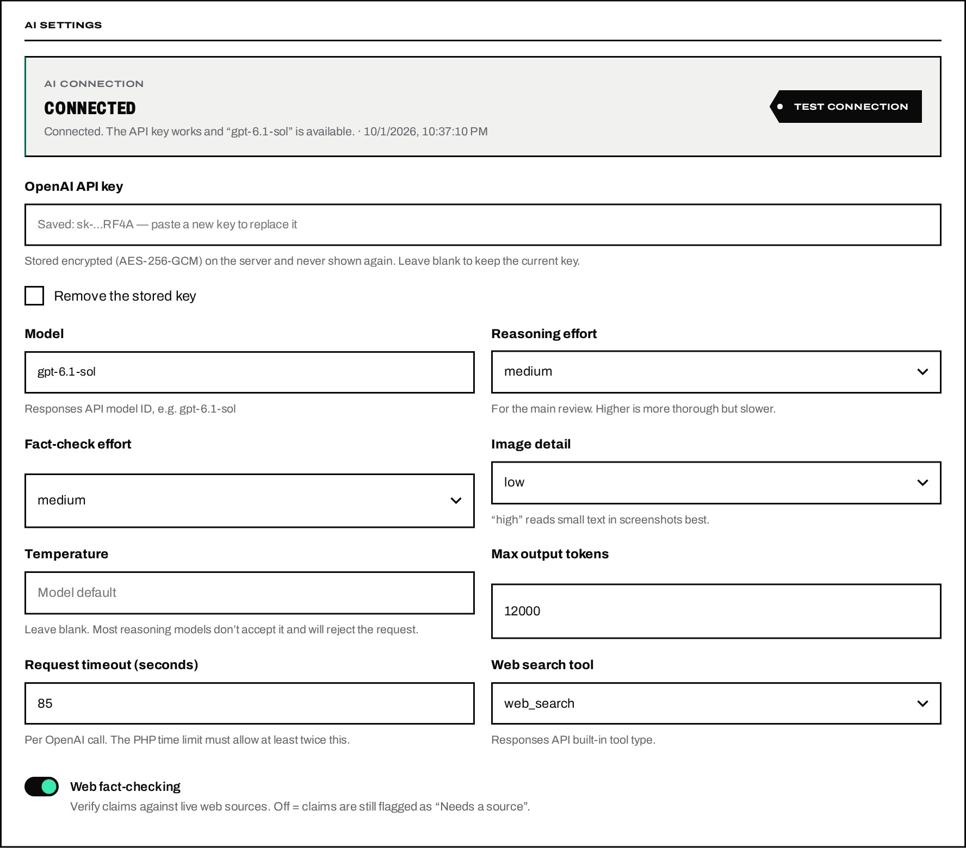
Note. Screenshot of the T.A.P. administration panel (restricted area), captured on October 2, 2026. Figures shown are anonymous aggregate counts; no post content is stored.
Figure 24
Check Toggles and Site Settings
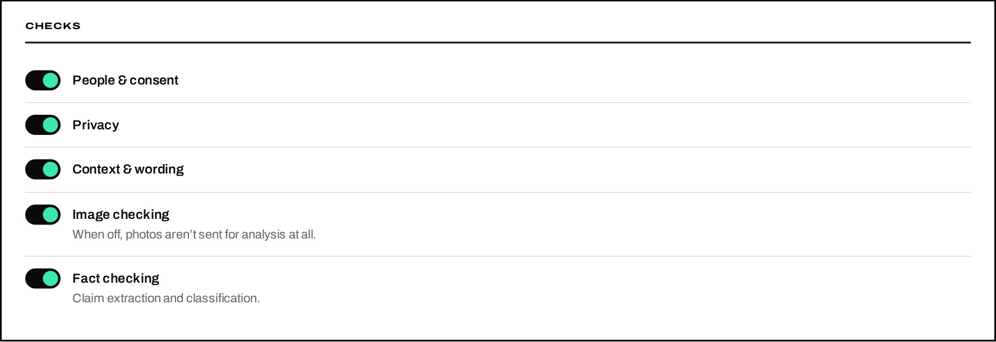
(a) Enable or disable individual checks
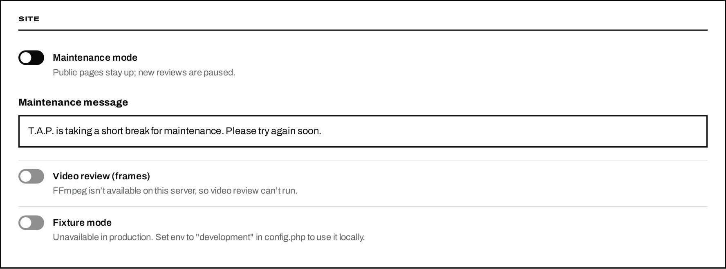
(b) Maintenance mode and optional features
Note. Screenshot of the T.A.P. administration panel (restricted area), captured on October 2, 2026. Figures shown are anonymous aggregate counts; no post content is stored.

F21 and F22. Audit Log and Account Management
The audit log lists sign-ins, failed sign-ins, settings changes, API key changes, connection tests and maintenance-mode changes, with the administrator, time and a short reference derived from a one-way hash of the IP address. Secret values are never recorded. The Account page allows the administrator to change the password, which requires the current password and enforces a minimum length.
Figure 25
Audit Log
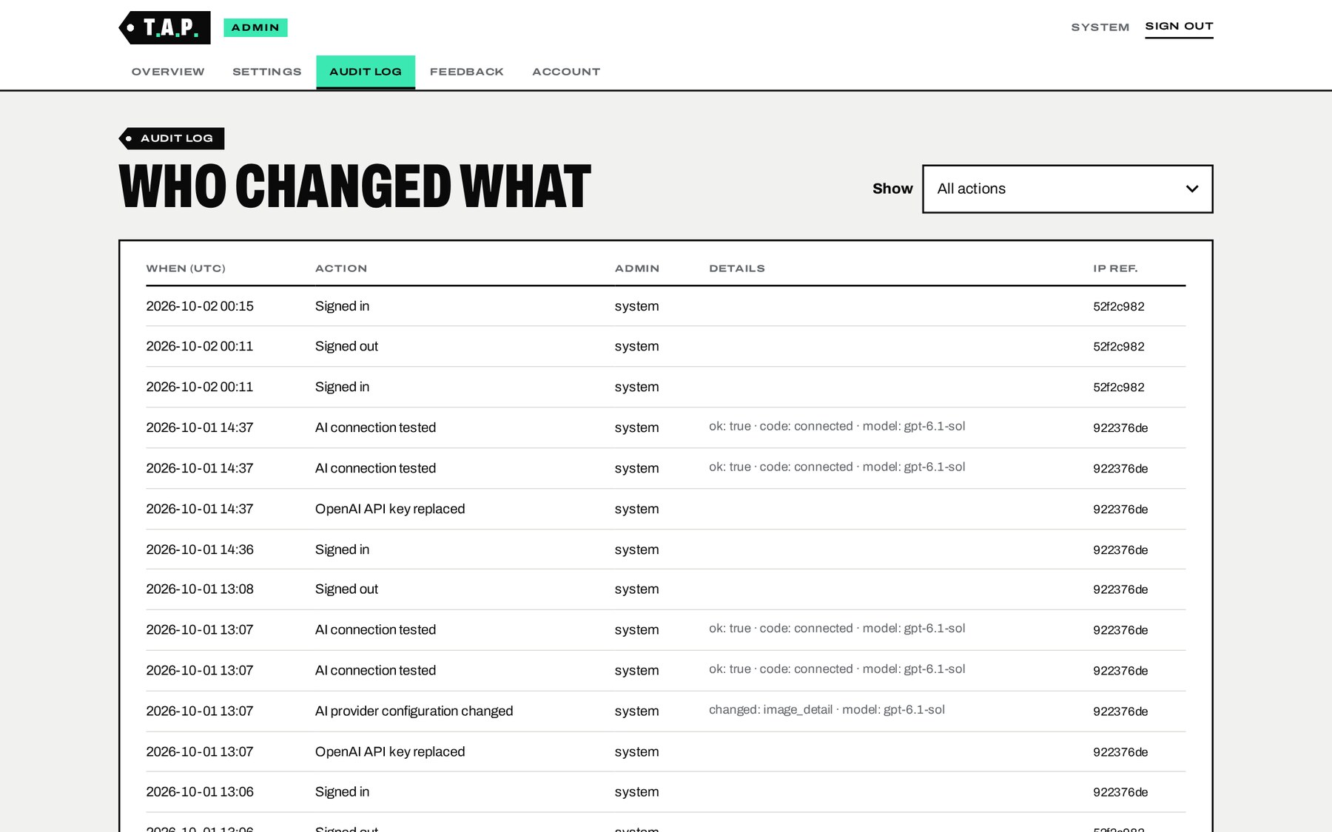
Note. Screenshot of the T.A.P. administration panel (restricted area), captured on October 2, 2026. Figures shown are anonymous aggregate counts; no post content is stored.
Figure 26
Account Page (Change Password)
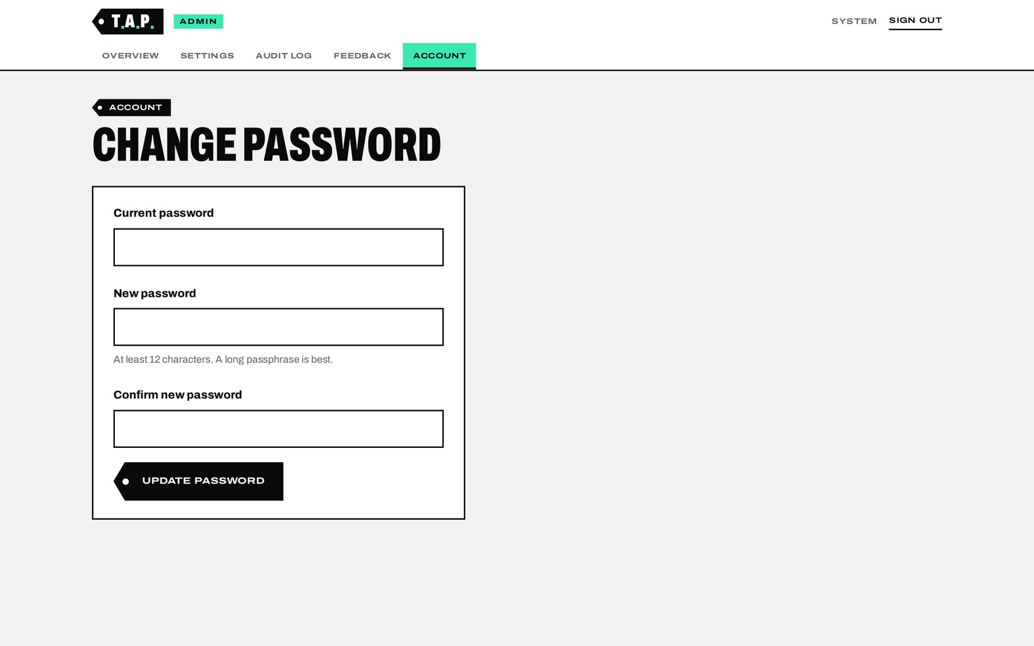
Note. Screenshot of the T.A.P. administration panel (restricted area), captured on October 2, 2026. Figures shown are anonymous aggregate counts; no post content is stored.

F23 and F24. Secure Installer and Scheduled Cleanup
A one-time web installer checks the server requirements, connects to the MariaDB database, creates the tables, writes the configuration file with a newly generated encryption key, and creates the first administrator. To prevent a stranger from claiming a fresh deployment, the installer requires a setup token that can only be read from the server’s file system, and it locks itself after completion. A scheduled cleanup job, run every 15 minutes, deletes stale temporary files, expired rate-limit records, old anonymous statistics and expired sessions. These two features operate without a regular user interface and are therefore not illustrated with screenshots.

5. Non-Functional Features
In addition to its functions, T.A.P. was designed to meet the quality attributes summarized in Table 5.
Table 5
Non-Functional Features (Quality Attributes)
Attribute | Implementation in T.A.P.
Privacy | No storage of drafts, images, names, links or AI output; anonymous counts only; temporary files deleted within the request; IP addresses stored only as keyed one-way hashes; no tracking or third-party scripts; AI requests sent with storage disabled.
Security | Strict Content Security Policy; CSRF protection on every write; prepared SQL statements; output escaping; magic-byte validation and re-encoding of uploads; rate limiting; brute-force protection; encrypted API key; secure, HTTP-only, SameSite cookies; HTTPS with HSTS; private files kept outside the web root (OWASP Foundation, 2021).
Reliability | Automatic retries with back-off for temporary AI errors; independent fact-check pass; graceful degradation when images or web search are unavailable; draft preserved on every error.
Usability | Three-step flow; plain, calm microcopy (for example, “Worth checking,” “Consent unclear”); no sign-up; consistent tag metaphor; findings linked to the exact text or image region.
Accessibility | Keyboard navigation, visible focus states, form labels, screen-reader status announcements, sufficient contrast, labels that never rely on color alone, and reduced-motion support (W3C, 2023).
Performance | No front-end framework or build step; one self-hosted font file; on-device image compression; long-term caching of versioned assets; progressive display of results.
Portability and maintainability | Runs on standard shared hosting (Apache, PHP 8.2, MariaDB) without Node.js in production; clear separation of presentation, routing, business logic, AI provider logic and data; configurable model and limits.

5.1 Technology Stack
Table 6
Technology Stack
Layer | Technology
Front end | Semantic HTML5, hand-written CSS, vanilla JavaScript (no framework); Archivo variable font (SIL Open Font License)
Back end | PHP 8.2 with a lightweight custom router and PDO; clean URLs through Apache .htaccess rewrite rules
Database | MariaDB 10.11 (InnoDB, utf8mb4)
Artificial intelligence | Large language model accessed through the OpenAI Responses API (model configurable by the administrator), with structured outputs and the built-in web search tool
Hosting and security | cPanel shared hosting, Apache, AutoSSL (Let’s Encrypt) certificate, Cloudflare proxy

6. Limitations of the System
The following limitations are acknowledged:
- AI judgments can be wrong. The review may miss issues or flag content that is acceptable; it is presented as a second look, not a final ruling.
- Image regions are approximate. As seen in Figure 12, the marked areas may not align precisely with the detail; the interface states this explicitly.
- Fact-checking depends on available sources. Claims about very recent, local or private events often return Could not verify.
- No legal advice and no consent on others’ behalf. The system can remind the user to ask but cannot grant permission.
- Processing time. A full review with photos and fact-checking typically takes about one to two minutes.
- Video is supported only as still frames and only where the server provides FFmpeg; it is disabled on the current deployment.
- Language. The interface is in English; findings are returned in the draft’s language where possible.

7. Conclusion
T.A.P. (Tag. Ask. Post.) converts the advice “think before you post” into a practical, privacy-respecting checkpoint. Its functions address the five problems identified in this proposal: consent (F5, F6), factual accuracy with verifiable sources (F7), personal-information exposure in text and images (F3, F8, F9), misleading or harmful wording (F10, F11), and the risk of a review tool becoming a data store itself (F16). The target users are primarily young adults aged 18 to 34 of all genders who post frequently from mobile devices, with secondary segments of guided teen users, adults and parents, and institutional page administrators. The working system demonstrates that these checks can be delivered in a calm, mobile-friendly interface that informs users while leaving the final decision to them.

References
Chua, Y. T. (2025, June 17). Philippines. In Reuters Institute digital news report 2025. Reuters Institute for the Study of Journalism. https://reutersinstitute.politics.ox.ac.uk/digital-news-report/2025/philippines
Data Privacy Act of 2012, Republic Act No. 10173 (2012). National Privacy Commission. https://privacy.gov.ph/data-privacy-act/
Gottfried, J., & Park, E. (2025, November 20). Americans’ social media use 2025. Pew Research Center. https://www.pewresearch.org/internet/2025/11/20/americans-social-media-use-2025/
Kemp, S. (2025, February 25). Digital 2025: The Philippines. DataReportal. https://datareportal.com/reports/digital-2025-philippines
OpenAI. (n.d.). Your data [Platform documentation]. Retrieved October 2, 2026, from https://platform.openai.com/docs/guides/your-data
OWASP Foundation. (2021). OWASP top 10:2021. https://owasp.org/Top10/
World Wide Web Consortium. (2023). Web content accessibility guidelines (WCAG) 2.2. https://www.w3.org/TR/WCAG22/

Appendix A: Sample Inputs Used for the Screenshots
All sample content below is fictitious and was created only to demonstrate the system. Real people, addresses and contact details were not used.
Sample Post A (Figures 4–8, 10a and 11–16). Platform: Instagram. Audience: Public. Tagged people: Sarah, Jon. Images: (1) an illustration of three people in front of a house numbered 24; (2) a mock screenshot of a chat with “Coach Ramon” containing a phone number, an e-mail address at the reserved example.com domain, and a gate code. Caption:
“Moving-in weekend with @sarah.k and Jon! Finally got the keys to our new place at 24 Linden Row. Fun fact: our street was just voted the safest neighborhood in Metro Manila. Housewarming next Saturday, everyone is invited!”
Sample Post B (Figures 9 and 10b). Platform: Facebook. Audience: Public. No images. Caption:
“Training starts this week for our Mt. Apo climb next month! Fun facts for the team: Mount Apo is the highest mountain in the Philippines, and its summit is about 3,500 meters above sea level. Who is joining us?”
Sample Post B deliberately contains one accurate claim and one inaccurate figure in order to demonstrate the Supported by available sources and Conflicting information outcomes.

